Image | 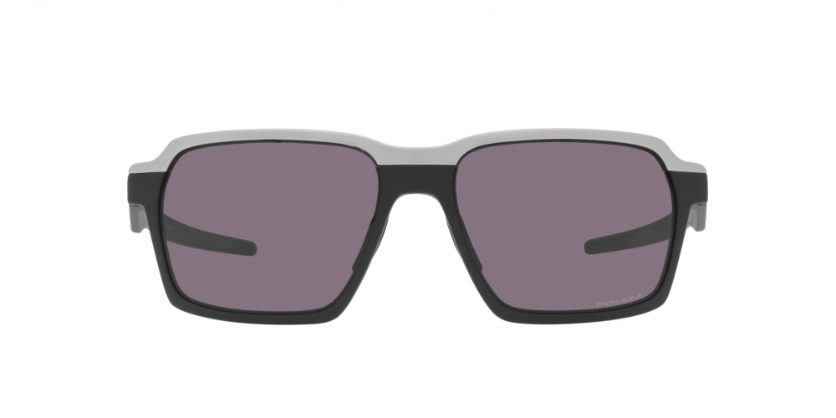
Brand | OAKLEY
Model Name | PARLAY MATTE BLACK
Price | RS 2499
PRODUCT DETAILS

